Buzzer Interfacing

Description:
The Buzzer Interfacing project demonstrates how to interface a buzzer with an Arduino to produce sound alerts.
A buzzer is an audio output device that generates sound when an electrical signal is applied.
This project is commonly used in alarm systems, notification systems, and warning indicators
Block Diagram:
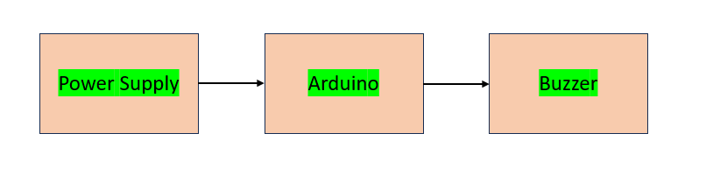

Pinout / Circuit Connection:
Arduino Pin 9 → Buzzer (+)
Buzzer (–) → GND
Power supply: 5V (from Arduino USB or adapter)

Components Required:
Arduino Uno / Nano
1 x Buzzer (Active)
Jumper wires
Breadboard

Working Principle:
The project works on the principle of digital output control.
When Arduino sends a HIGH signal to the buzzer pin, current flows through the buzzer and it produces sound.
When the signal is LOW, the buzzer stops producing sound.

Operation (Step-by-Step):
Connect the buzzer to the Arduino as per the circuit connection.
Upload the buzzer interfacing code to the Arduino board.
Power ON the Arduino using USB or adapter.
The buzzer will turn ON for a fixed duration.
After the delay, the buzzer will turn OFF automatically.
This process repeats continuously.

Arduino Code:
int buzzerPin = 9;

void setup() {
pinMode(buzzerPin, OUTPUT);
}

void loop() {
digitalWrite(buzzerPin, HIGH); // Buzzer ON
delay(1000); // 1 second delay
digitalWrite(buzzerPin, LOW); // Buzzer OFF
delay(1000); // 1 second delay
}

Conclusion: (Predefined/self-written)
The Buzzer Interfacing project helps students understand how Arduino controls audio output devices.
It is useful for learning alert and notification systems and forms the basis for more advanced alarm-based applications.
For Your References:
[1] Arduino, “Tone Function,” Arduino.cc. [Online]. Available: https://www.arduino.cc/reference/en/language/functions/advanced-io/tone/. [Accessed: 27-Aug-2025].
[2] Arduino, “Digital Write Function,” Arduino.cc. [Online]. Available: https://www.arduino.cc/reference/en/language/functions/digital-io/digitalwrite/. [Accessed: 27-Aug-2025].

